CS 255 System Design Document Template

This template lays out all the different sections that you need to complete for Project Two. Each section has guidance to prompt your thinking. You will need to continually reference the interview transcript as you work to make sure that you are addressing your client’s needs. There is no required length for the final document. Instead the goal is to complete each section based on what your client’s needs are. Remove this note when you are finished, and replace all bracketed text with the relevant information.

UML Diagrams

UML Use Case Diagram
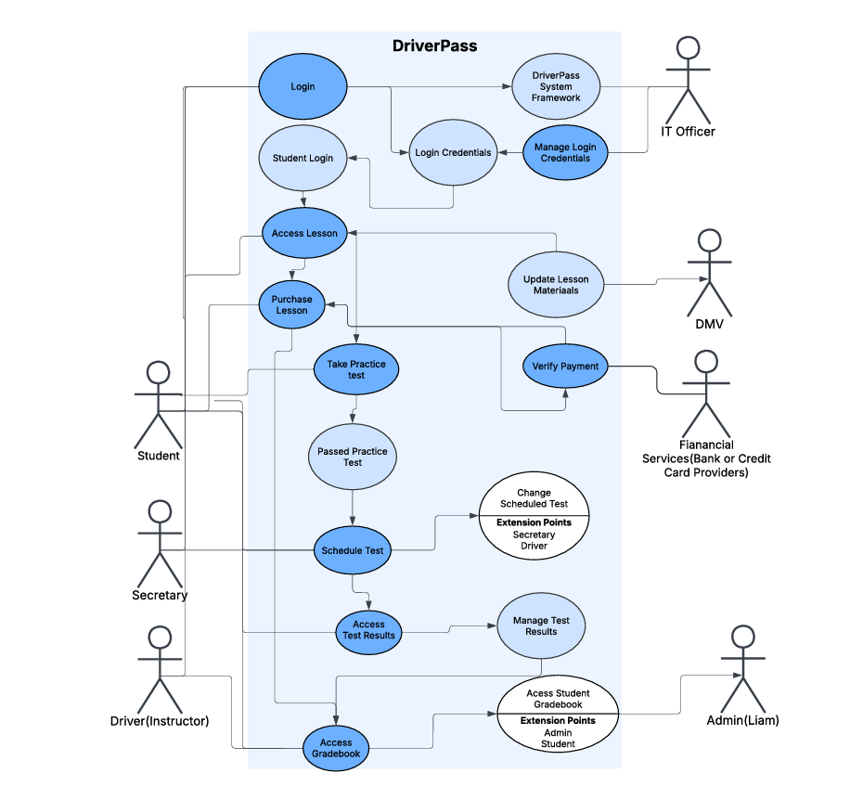

UML Activity Diagrams
Driver Activity
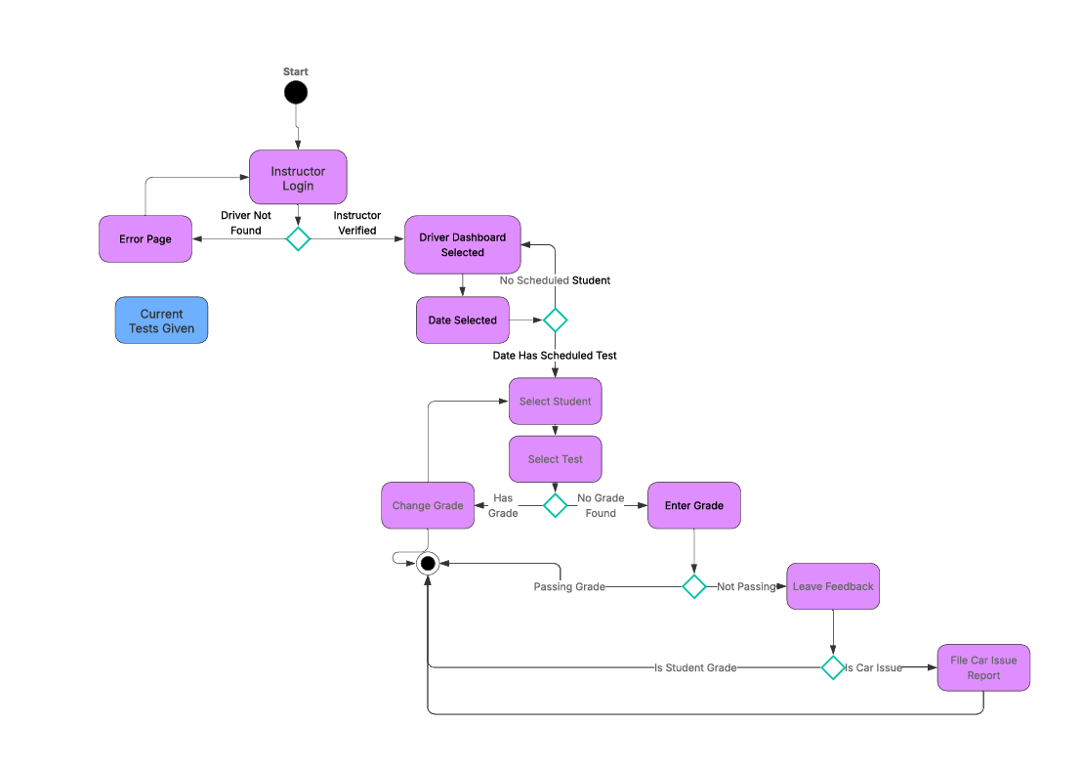

Student Activity
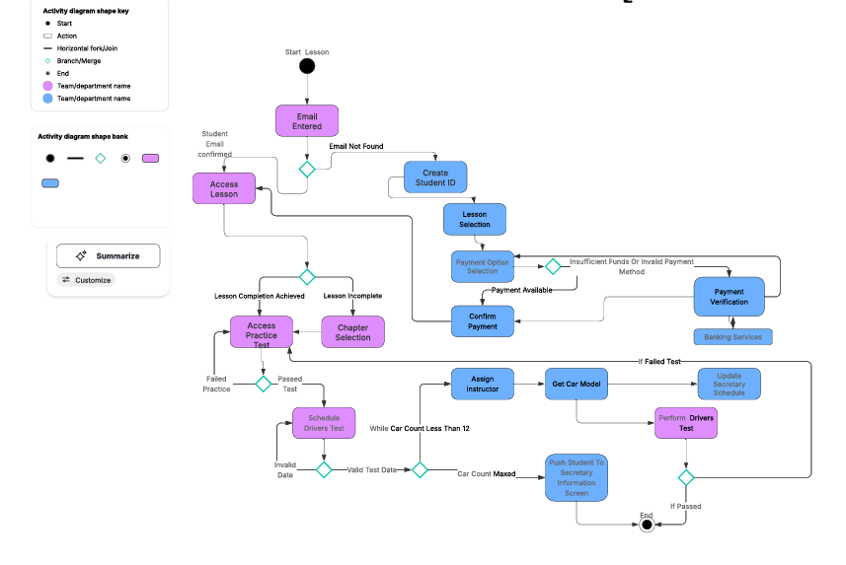

UML Sequence Diagram
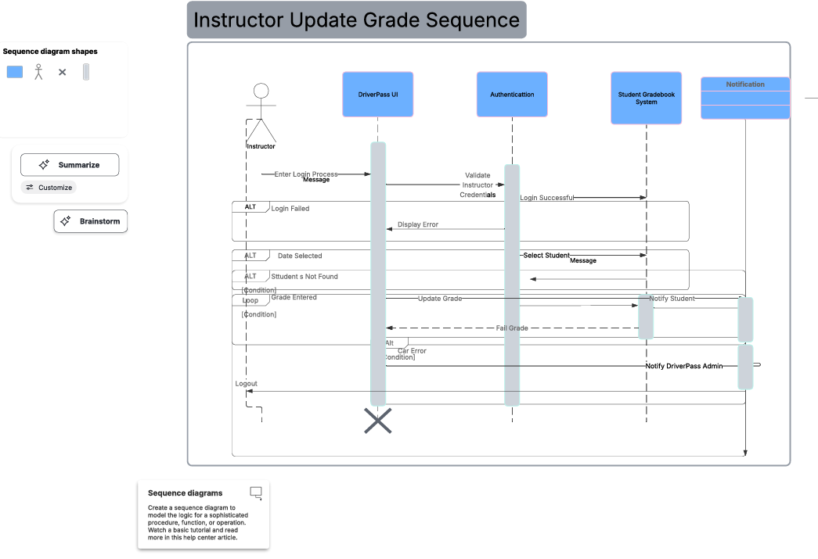

UML Class Diagram
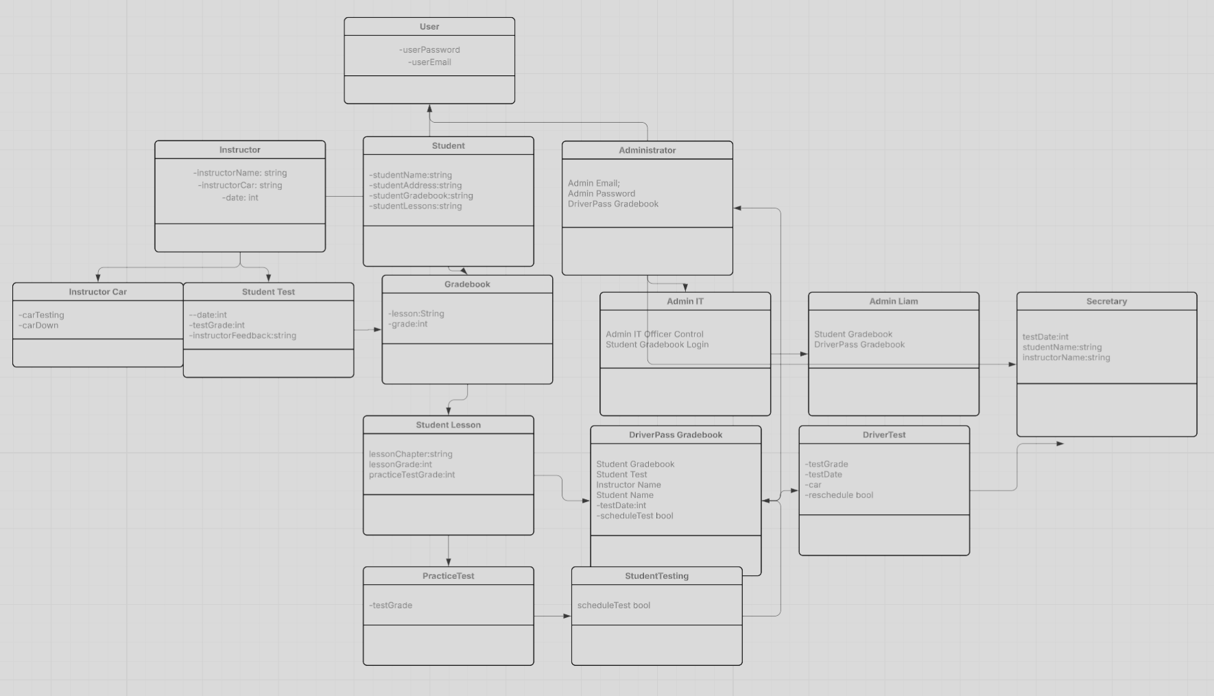

Technical Requirements
• SQL Database for student names, reservations made, lessons available, gradebook database, Dmv Update database
o Users information should be backed up to a database for login credentials and gradebook data/ lesson data access
o Secretary and Drivers should have access to the reservations database for up to date knowledge on scheduled tests and should be checked if a new reservation is requested by a student
o Database of DMV lessons should update regularly and be used for lesson availability
o Gradebook database should be updated by the lesson completion by a student or the update to a driving test score by a driver

Security Constraints
• Securely store any user information like credit card details and address of user outside the gradebook tracking of user
• Login system security encryption
• Role based Login access for user role based control measures(Student user, Admin user, IT user, Secretary user, Driver user)

